E. Tseimakh, A. Levin, O. Ananko, S. Kuznetsov,
N. Khvastunova, P. Zimonin

Application of valvular bronchoblocking in complex treatment of acute abscess of left lung complicated by hemorrhage in combination with multitrauma

Regional State Institution of Public Health Care Service “ Regional Tuberculosis Dispensary”, Chair of operative surgery and topographical anatomy of Altai State Medical University, City hospital № 1, Barnaul

Severe multitrauma is one of the tree main reasons of death rate; moreover among people of 40 this reason takes the fist place. Lethality rate during severe multitrauma reaches 45% [1, 2].
Pulmonary hemorrhage is a painful, often fatal complication of a number of lung diseases [3-5].
We present surveillance of successful treatment of acute abscess complicated by hemorrhage in combination with multitrauma by the method of valvular broncoblocking by an original appliance (Patent “A method of treating lung tuberculosis” № 2002133917 23.03.2004).
Patient Sh., 31, was taken to hospital in an hour after he had been injured (beaten by unknown people) with complaints on intense headache, nausea, emesis, severe pains in the left part of the chest and lower part of abdomen, weakness. From the case history it was found out that 2 weeks before the trauma the patient had been treated in therapeutics department of one of city hospitals on cause of abscess pneumonia of lower lobe of left lung.
When taken to hospital the patient was in grave condition. Dermal integument: pale. Body temperature: 38.2 degrees Calcium. Number of breathings: 24/minute. Pulse: 104 strokes a minute, weak. Blood pressure: 100/60. Degree of consciousness: moderate torpor, decrease of criticism, partly disoriented in place and time. Nasal and oral hemorrhage. Contused wounds of frontal and temporal areas. Paraorbital hemorrhage. Pupils are round D=S, photoreaction is vivid, bilateral small-swinging horizontal nystagmus. Muscular tonus remains, no sensitivity disorder. Babinski’s sign is positive on both sides, rigidity of neck muscles is cross two fingers. Kerning’s symptom is negative. In Romberg’s position the patient is unstable, coordination tests are performed with by-hits from both sides.
08.10.2004 lumbar puncture was taken. Liquor is pink, slightly turbid. Microscopy: numerous erythrocytes – 10200 in mm${}^{3}$, protein – 0.297 ‰, leucocytes – 5 in mm${}^{3}$, Pandy’s test – positive. Radiographs of the spinal column show 0.5 cm reduction of height of vertebral bodies Th${}_{\text{XI}}$, Th${}_{\text{XII}}$. Radiographs and computer tomograms of chest organs show cavernous formation 5×5 cm in size with clear inner shape and degraded outer shape due to perifocal infiltration of lung tissue on the left in X-segment (Drawing 1). During computer tomography skull base fracture in the areas of frontal and middle cranial fossa was observed. There is brain contusion. The focus of contusion is in left frontal lobe, there is epidural blood clot 3-4 ml in volume in right frontal lobe. During ultrasonic study of abdominal cavity a small amount of free liquid is observed under right lobe of liver. Laparoscopy shows 200 ml of liquid blood in abdominal cavity, hematoma in the area of mesentery of descending part of colon.
On the basis of clinical, laboratory and instrumental methods diagnosis was made out as severe multitrauma. Acute craniocerebral injury, skull base fracture in the areas of frontal and middle cranial fossa, severe brain contusion with focus of contusion in left frontal lobe. Epidural blood clot V${}_{3−4}$ in right frontal lobe, contused wounds of frontal and temporal areas. Blunt abdominal injury. Rupture of parenchymatous organ. Hemoperitoneum. Closed uncomplicated compression fracture Th, Th${}_{\text{XII}}$. Acute post pneumonic abscess of X-segment of left lung.
The patient was operated on urgent indications. Laparotomy under narcosis was held. During the revision of abdominal cavity a flat non-tense hematoma spreading on root of colon was found in the area of left kidney. Left kidney was exposed. In the area of renal entry on anterior and posterior surface of the kidney there was found a rupture 1.0×0.5 cm and 1.0×1.0 cm going through the entry not penetrating into renal pelvis. Ruptures were mended by atraumatic needle. Hemostatic sponge is put on anterior surface of the mended rupture. No other injuries are found in abdominal cavity. 3 drains are fixed in paranephric tissue, 1 – in abdominal cavity, 1 – in pelvis minor. Operative wound is tightly mended in layers.
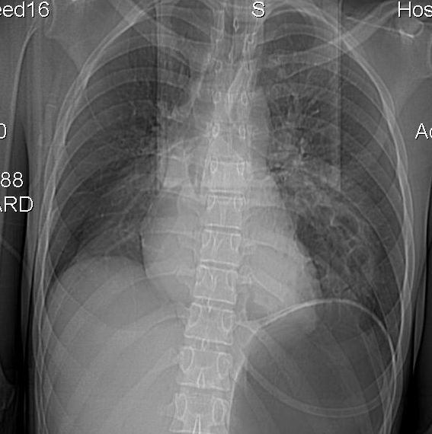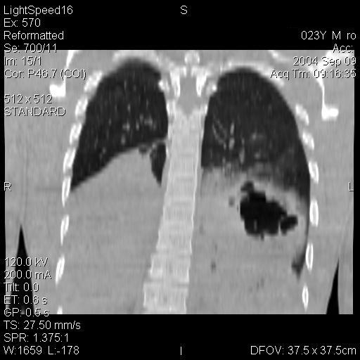

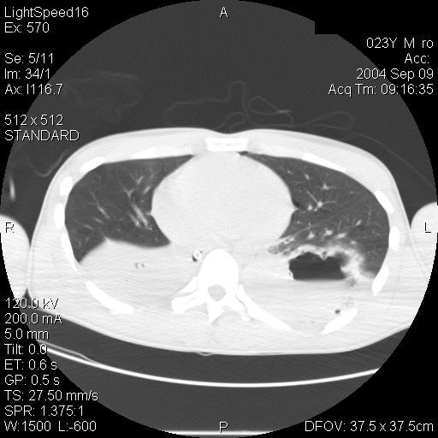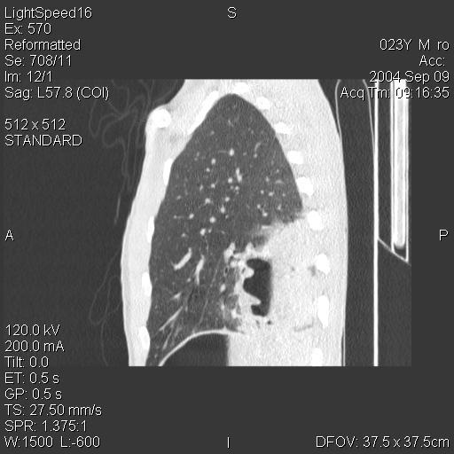

Drawing 1. Radiographs and computer tomograms of patient Sh., 31 when taken to hospital

After the operation artificial pulmonary ventilation was applied due to inadequate spontaneous breathing. 09.09.2004 there suddenly appeared pulmonary hemorrhage of II grade with 400 ml dark blood emitting at once. For this reason urgent bronchofibroscopy was held. It was found out that on the right BS${}_{4}$, BS${}_{5}$, BS${}_{6}$, BS${}_{7}$, BS${}_{8}$, BS${}_{9}$, BS${}_{\text{10}}$ are obturated by clots of dark blood with thick mucus up to the bronchus of VI level, on the left upper lobe bronchus is filled with blood clots. Patency of bronchus of all levels was restored after sanation. The source of bleeding was BS${}_{\text{10}}$ on the left. Taking into account high possibility of relapse of hemorrhage, severity of the patient’s condition and in order to prevent asphyxia by blood, bronchus of basal pyramid on the left was blocked by elaborated original appliance.

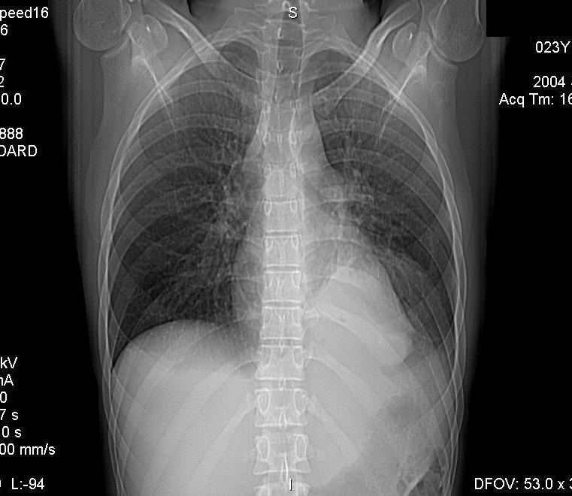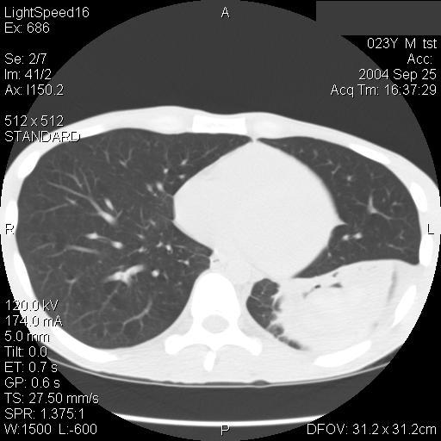

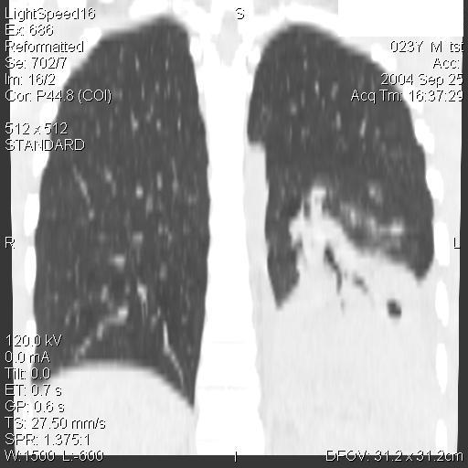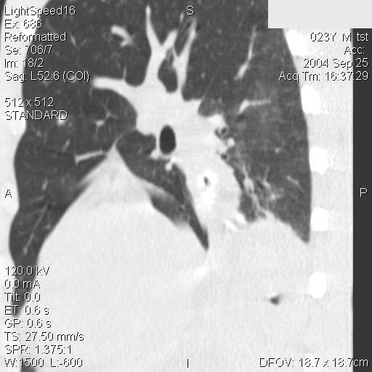

Drawing 2. Radiographs and computer tomograms of patient Sh., 31, after valvular bronchoblocking.

Test radiographic study shows that on the left there is atelectasis of the segments of basal pyramid in shape of triangular shadow with the top pointed to the root of the lung. Left cupular of diaphragm is raised (Drawing 2). Ultrasonic study shows triangular heterogeneous hyperechotic spot of tissue 76.4×89.5×98.6 mm in size up to 353 cm${}^{3}$ in volume in lower lobe of left lung.
After valvular bronchoblocking a course of massive antibacterial therapy (by Claforan, Ceftriabolum, Amikacin) was continued. Cryoplasmetic-antienzymatic complex worked out in the clinic [6] was also used together with infusive, disintoxication therapy. Drainages in abdominal cavity were removed in three days after the operation. For seven days assisted pulmonary ventilation was applied. In resuscitation department and in department of severe multitrauma the patient was transfused 2300 ml of Polyglucinium, 2400 ml of Rheopolyglucinium, 970 ml of preserved packed red blood cells of the same blood group and 900 ml fresh frozen plasma.
16.09.2004 test bronchoscopy shows that patency of all lobar, segmental bronchus is preserved. The valve is in the bronchus of basal pyramid on the left. Proximal of the valve in the bronchus of basal pyramid there are some signs of “old” blood and a little of mucoid sputum. There is no blood access into bronchial tree.
Due to the therapy the patient’s condition significantly improved. “Meningeal signs” disappeared, intoxication and respiratory failure decreased, pulmonary hemorrhage did not repeat.
22.09.2004 cramp-like pains appeared in lower part of abdominal cavity mostly on the right. There was emesis by stagnant intestinal contents. There was no passage of gases. Survey radiograph showed Kloiber’s symptom in hypergastrium mostly right. Conservative treatment (infusive therapy, anticholinterase preparations, cleansing enema) brought no effect. 22.09.2004 the patient was urgently operated due to the diagnosis of early adhesive small bowel obstruction. Videolaparoscopic adhesiotomy, nasogastral intubation of small bowel and drainage of abdominal cavity were held.

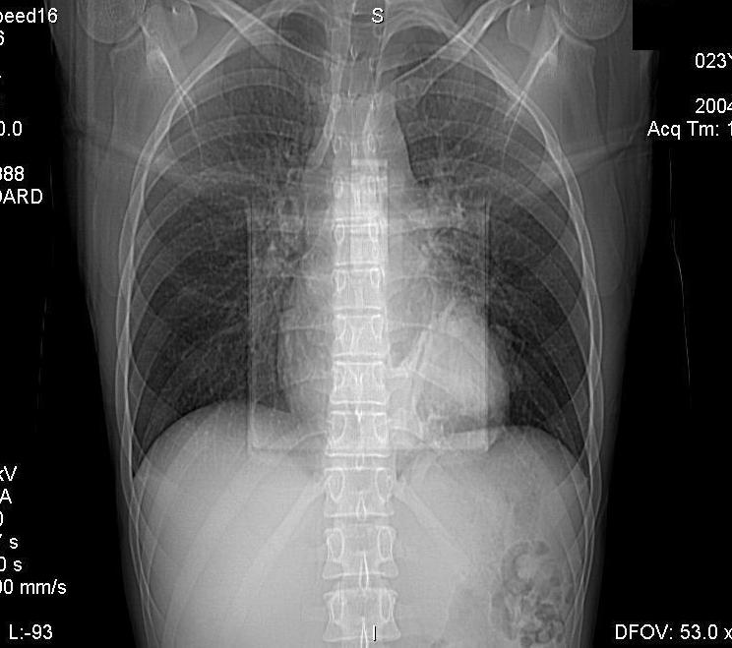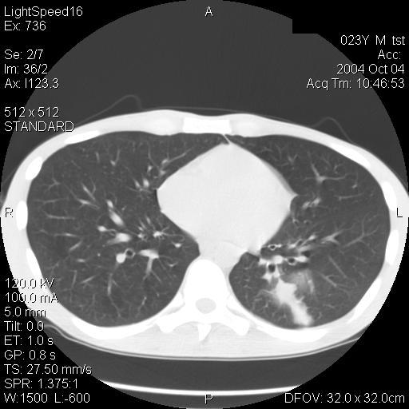

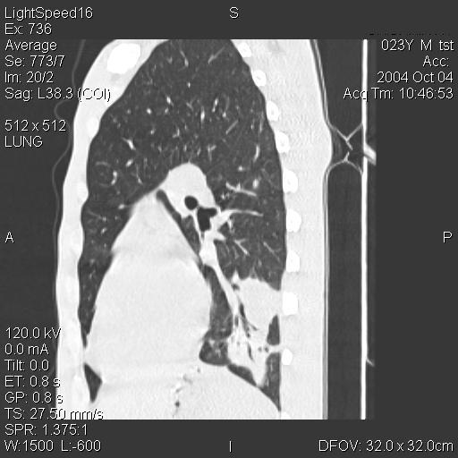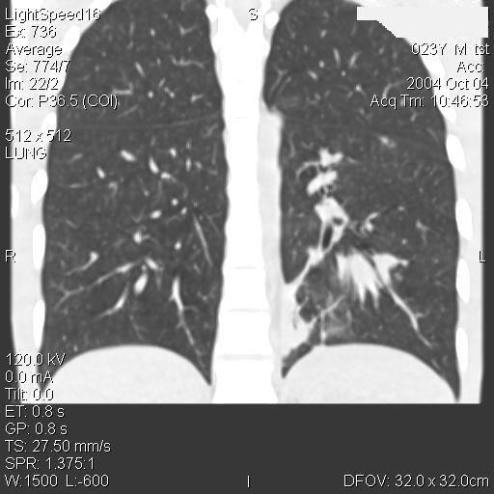

Drawing 3. Radiograph and computer tomogram of patient Sh., 31 after the removal of bronchoblocker

Post operation treatment is smooth. Active peristalsis has appeared, passage of the contents along the bowels restored. 24.09.2004. drainage and nasogastral tube were removed. 29.09.2004 bronchofibroscopy was held. Bronchoblocker was removed by biopsy forceps. Mucous tunic of the bronchus of basal pyramid in place of valve location is slightly edematic and hyperemic. Radiographs and computer tomograms of the chest organs in view of S${}_{\text{10}}$ of left lung shows local pneumosclerosis (Drawing 3). Drawing 4 presents virtual bronchoscopy.

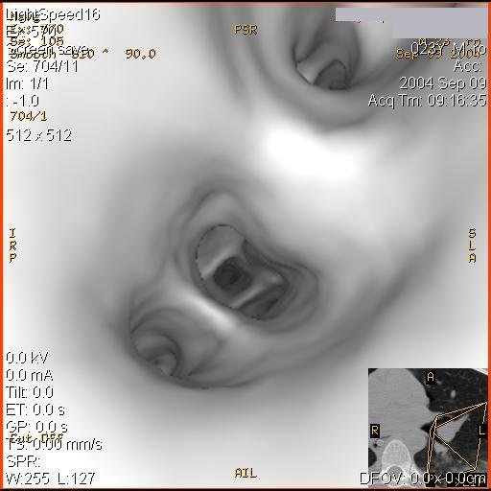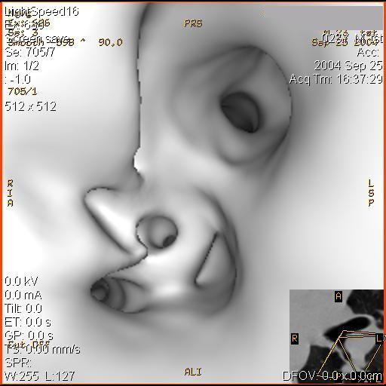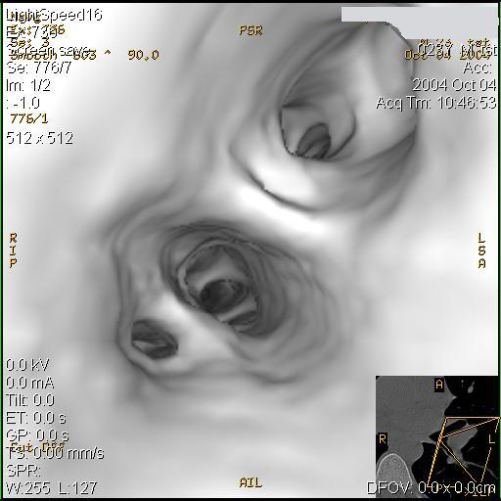
а) б) в)
Drawing 4. Virtual bronchoscopy of patient Sh., 31:
- when taken to hospital
- after the installation of the blocker in the bronchus of basal pyramid of left lung (pointed by the arrow)
- after the removal of the bronchoblocker

The patient was discharged from hospital in satisfactory condition. Test examination was held in 6 months. The patient is healthy, got back to his job of policeman.
Consequently, the use of endobronchial reverse valve enabled safely stop pulmonary hemorrhage in case of acute abscess of left lung in combination with multitrauma and contributed to the patient’s recovery.

Bibliography
- Ermolova A.S., Abakumova M.M., et. Medical aid during multitrauma. – Yaroslavl, 1997. – 218 p.
- Seleznev S.A., Cherkasova V.A., et. Multitrauma and traumatologic disease. – Perm, 1999. – 330 p.
- Struchkov V.I., Nedvedskaya L.M., Dolina O.A., Biryukov Yu.V. Chronic suppurative pulmonary diseases complicated by hemorrhage. – Moscow, 1995. – 256 p.p.
- Utkin M.M., Kirgintsev A.G., Sviridov S.V., Sergeev I.E. Tactics of anesthesiologist- expert in resuscitation during pulmonary hemorrhage // News bulletin of intensive therapy. – 2004. – №2. – p.p. 71-75.
- Kirgintsev A.G. Tactics of surgical treatment of patients with pulmonary hemorrhage. Abstract of thesis for the degree of Doctor of medicine. – Moscow, 2002.
- Tseimakh Y.A., Peleganchuk V.A., Bondarenko A.V., et. Use of cryoplasmetic-antienzymatic complex in treating cases of severe multitrauma // News bulletin of intensive therapy. – 2003. – №3. – p.p. 43-45.

